Student Information
Handbook 2022

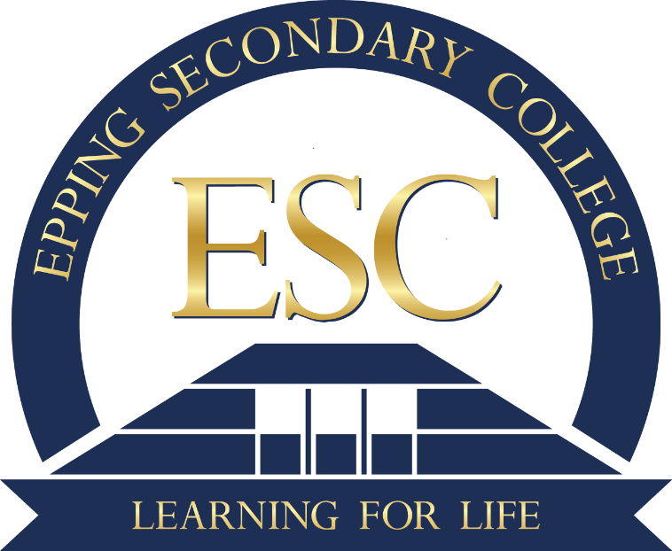

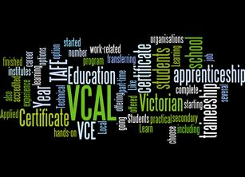

“Achieving Your Best”
The final years of secondary schooling are very important and it is vital that you give very careful consideration to your career pathway choices and key focus area when selecting VCAL as your final years program option. You have the opportunity of working in and studying units of work associated with your personal growth, educational development and career pathway journey. Make sure you select options that you are interested in and enjoy, as well as those that you are good at. It is also important that you select courses that keep your options open in case your interests and aspirations change.
At Epping Secondary College we offer a broad range of opportunities for students undertaking a VCAL program. Many students will continue to complete a combination of TAFE and/or certificate units and Structured Workplace Learning opportunities whilst undertaking a mix of VCE subjects and VCAL units of work. In all cases further development of their work readiness skills and vocational future choices will be of paramount importance along with their personal growth.
Features of the Post Compulsory Pathways offered by Epping Secondary College include:
- a supportive and caring environment for our students within the Senior Years
Programs of the college
- VET in Schools programs which enable students to complete VET in Schools or TAFE certificates within the usual two year time span.
- flexible enrolments where students are able to move to and from VCE/VCAL during Year 11.
- opportunities for students to be involved in leadership through the extensive school leadership program including forums, captains, ambassadors and the SRC.
- provision of the qualification, the Victorian Certificate of Applied Learning (VCAL). The key characteristics of the program are to develop personal, social and employability skills and knowledge. There is a strong emphasis on partnerships with other organisations such as TAFE, adult education providers, community and voluntary groups and employers, with a focus on applied learning.
Make sure that you read through this handbook carefully as it is crucial that you make the right choices for you. Speak with your teachers, talk to your parents and brothers and sisters or friends who have completed their VCAL. Advice and information can also be obtained through the Careers Co-ordinator, Mr Dean Malcolm and current VCAL Co-ordinator Penny Hysen
It is an important decision that you are making and it is up you to be fully informed.
It’s your future.

Ray Stevens
Leading Teacher
Alternate Learning Unit
Your Future Starts HERE

Victorian Certificate of Applied Learning

What is VCAL?
The VCAL gives you practical work-related experience, as well as literacy and numeracy skills and the opportunity to build personal skills that are important for life and work. And like the Victorian Certificate of Education (VCE) it is a recognised senior secondary qualification.

Students who do the VCAL are likely to be interested in going onto training at a Technical and Further Education (TAFE) institute, starting an apprenticeship, or getting a job after completing school. However, if you start your VCAL and then decide the VCE is the right option for you after all, it won’t be too late to change your mind. In fact, any VCE units you complete as part of your VCAL will count towards your VCE, should you decide to transfer between certificate courses.

In the case of the Epping S.C. VCAL program students undertake VCE English and VCE Mathematics at Year 11. Both subjects act as accredited Intermediate Literacy and Numeracy VCAL outcomes.

All VCE subjects undertaken will count towards a variety of VCAL outcomes.

The VCAL’s flexibility enables you to undertake a study program that suits your interests and learning needs. This includes VCE subjects as well as VETis and TAFE courses.
Fully accredited modules and units are selected for the following four compulsory strands:

- Literacy and Numeracy Skills
- Work Related Skills
- Industry Specific Skills
- Personal Development Skills

If you successfully complete your VCAL, you will receive a certificate and a statement of results that details the areas of study you have completed.

Applied (hands-on) learning is an integral part of the VCAL curriculum. It provides students with real life experiences and direct exposure to industry.

VCAL provides Victorian businesses the opportunity to attract young people who want to take up an apprenticeship, employment and continue with their training.

What are the aims of VCAL?
The VCAL aims to provide students with the skills, knowledge and attitudes to make informed choices about pathways to work and further education.
The principles underpinning the VCAL are:
- Accredited pathways for secondary students
- Tailoring a program to suit students’ interests
- Personal development
- Development of work related and industry specific skills
These principles are within the context of applied learning. In the VCAL these principles are shown through:
- The development of knowledge and employability skills that help prepare students for work and for participation in a broader society – family, community and lifelong learning.
- The development of knowledge and skills that assist students to make informed vocational choices and facilitate pathways to further learning and employment.

What are the qualifications?
The three qualification levels cater for a range of students with different abilities and interests. They also provide a progression of skills, knowledge and attitudinal development.
The VCAL is accredited at three levels:

- Foundation
Traditionally completed by students with intellectually or other disabilities or younger students. Can be completed over two years for students with significant learning needs. Involves a high level of teacher or aide support.

- Intermediate
Traditionally at ESC Intermediate is completed by year 11 students. Year 11 students at ESC are generally enrolled in VCE maths, English and I&E and intermediate Literacy, and Numeracy. Involves more complex skill development and only limited amount of support from teachers.

- Senior
Traditionally at ESC Senior is completed by year 12 students. Involves a complex level of skill development and students should be self-directed learners with a very limited amount of teacher support.
The following is an example of the different pathways a VCAL student can make possible

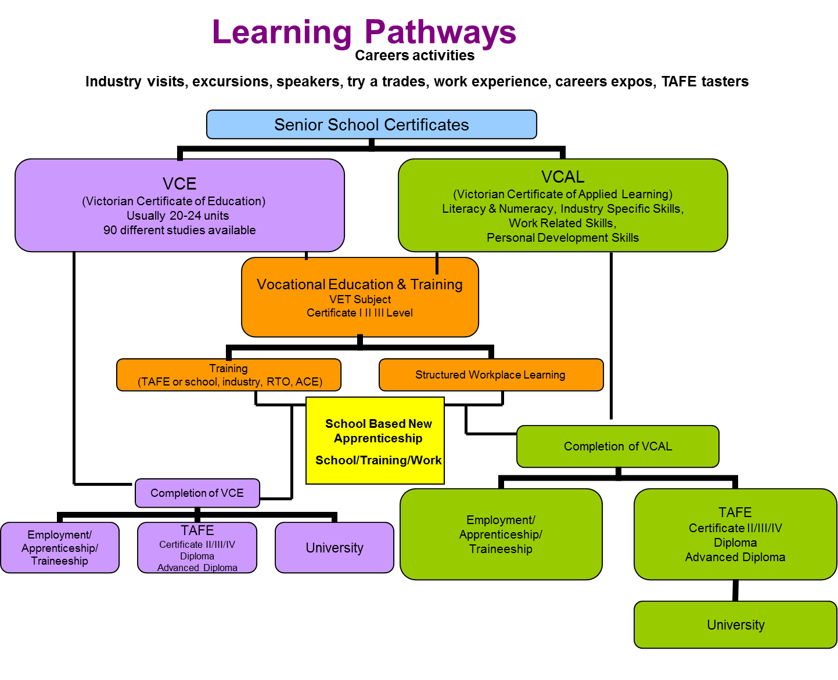
VCAL increases pathways for young people into further education, training and work
Through a focus on ‘hands-on’ learning VCAL students are equipped to make informed choices about their future career direction and decide if an apprenticeship, Vocational Education and Training (VET) qualification, further education or employment is the right choice for them. VCAL students are more likely to continue training in the industry of their choice, do an apprenticeship, or get a job after completing Year 12.
Completing a VCAL qualification is a recognised senior certificate and allows students to complete TAFE courses in a wide range of areas, and then move onto tertiary studies (University) if desired.

VCAL provides students with practical, work-related skills
As part of a VCAL program, students must undertake structured workplace learning one day per week across the school year on a designated day. Students must also undertake a Vocational Education Training in Schools (VETiS) or school-based apprenticeship or traineeship (SBAT) certificate along with their VCAL studies.

Students and skills
VCAL students are equipped with well-rounded literacy, numeracy, personal development, and industry specific and work related skills – skills that can make a great contribution to our industry and business sectors.

While VCAL programs are designed to suit the needs and interests of each individual, every VCAL student must complete fully accredited units and modules in the following four skill development strands.

STRAND 1
- LITERACY AND NUMERACY SKILLS
Your VCAL program must include literacy and numeracy subjects. These can be selected from VCAL literacy skills and VCAL numeracy skills units and/or VCE English and Maths units

STRAND 2
- INDUSTRY SPECIFIC SKILLS
Your VCAL program, at the Intermediate and Senior levels must include components of nationally recognised VET programs. However, you are not required to focus on, or complete, any single VET certificate. For example, you can choose to complete various modules or units from a range of VET certificates to meet the VCAL requirements, and gain experience in a range of vocational areas. The range of VET options is extensive and some examples are automotive, engineering, building and construction, hospitality, retail, multimedia, information technology, agriculture, horticulture, warehousing, hair and beauty, electro technology and civil construction.

STRAND 3
- WORK RELATED SKILLS
In order to develop employability skills, VCAL gives you the opportunity to undertake a structured work placement or a part-time apprenticeship/traineeship, or part-time work. You can also study units and modules that will help prepare you for work, for example occupational health and safety or job interview skills to better prepare you for the world of work.

STRAND 4
- PERSONAL DEVELOPMENT SKILLS
As part of your VCAL program you will participate in projects and activities in your community or school that will help develop your teamwork skills, self-confidence and other skills important for life and work.

Achieving Your Best
- Set goals to improve your skills in all subjects
- Aim not just for a ‘pass’ but for the best possible outcome YOU can achieve
- Approach all classes with an attitude that hard work, persistence and practice are the main ingredients for improvement, NOT intelligence!
- Remember that employers want to hire the ‘best possible person for the job’ not the person who is ‘OK’ or ‘A Nice Kid’, strive to be the best you can possibly be to enable you the best chance for future success.
- Achieving your best does not mean the same thing for each person.

The tri-partisan agreement and curriculum
All major curriculum decisions are made with parents and students, with the interests of the students in mind in regards to:
  - VET Programs
  - Individual Timetables
  - Specialised school programs
  - If students are finding any part of the VCAL program difficult for any reason, parent contact is made at the first available opportunity.
  - The earlier we know about information that is pertinent to student achievement the better.

Keeping up-to-date and accurate folios
- Each year, a random selection of schools and students are audited by the VCAA.
- It is essential that if we are audited we are able to submit folders that are complete, neat and organised to the VCAA
- It is the students’ responsibility to ensure folders are neat, organised and contain all the subject work.

SATISFACTORY COMPLETION OF A UNIT:
Satisfactory completion is a school based decision and students are given every reasonable opportunity to gain an “S” for an assessment task. Students are expected to complete assessment tasks for a unit during the semester in which the unit is undertaken. VCAL students are assessed by a number of outcomes (ranging between 6 - 8) for each subject across the unit. A student must successfully achieve competence in all outcomes to gain an ‘S’ for the VCAL unit.

Year 11 Educational Pathways 2022

VETiS - Vocational Education & Training in Schools: Offers students a vocational certificate with credits towards their VCAL. This qualification can provide students access to further training at TAFE institutes, and may improve their chances of employment.

VCAL - Victorian Certificate of Applied Learning: A “hands on” option that includes VET related work experience as well as literacy, numeracy and personal development skills.

SBAT - School Based Apprenticeships and Traineeships: Students who combine their VCAL with a part-time apprenticeship. As an apprentice trainee they receive wages and other benefits to which employees are entitled. Students complete their studies at ESC over 3 days, attend TAFE for 1 day, and work for 1 day per week.

TAFE - Tertiary and Further Education: Students can apply for a pre-apprenticeship or other programs at a TAFE. Must be done in early October-no guarantee of a place.

Students can apply for a
Year 10
2013

VET - Vocational Education and Training
Vocational Education and Training (VET) in the VCAL program combines general VCAL studies with vocational training and experience in the workplace. Students completing the VCAL MUST complete a VETiS program to satisfactorily complete their VCAL studies.

V.E.T. In Schools (VETiS) Programs 2022

Making the real world part of students VCAL studies

Vocational Education and Training in Schools (VETiS) programs are vocational studies approved by the Victorian Curriculum and Assessment Authority that function within the National Training Framework. Students undertake a combination of general VCAL studies and structured hands-on training and practice in industry.

VET in Schools programs enable students to complete a nationally recognised vocational qualification, the VET in Schools Certificate, whilst undertaking the VCAL within the usual two-year time frame. The programs that may be offered through Epping Secondary College in 2022 may include (please refer to the NMVC 2022 VET Handbook for more specific information):
- Certificate III in Laboratory Skills | - Certificate III in Aged Care
- Certificate II in Live Production, Theatre and Events | - Certificate II in Printing & Graphic Arts (Desktop Publishing)
- Certificate II in Manufacturing Technology | - Certificate III in Permaculture
- Certificate II in Music Industry (Foundation) | - Certificate II in Sustainable Energy
- Certificate III in Music Industry  (Technical Production) | - Certificate II in Telecommunications (Cabling)
- Certificate II in Automotive Technology Studies | - Certificate II & III in Creative Industries (Media)
- Certificate II & III in Beauty | - Certificate II in Dance
- Certificate II in Building & Construction (Bricklaying, Carpentry, Wall & Floor Tiling) | - Certificate II in Electro technology  (Shared Technology)
- Certificate II in Plumbing (pre-apprenticeship) | - Certificate III in Information Technology (Partial Completion)
- Certificate II & III in Hospitality) | - Certificate II in Engineering studies
- Certificate II in Outdoor Recreation | - Certificate II in Equine Industry
- Certificate II & III in Sport and Recreation | - Certificate II in Furnishing  (Pre-apprenticeship-cabinet Making)
- Certificate II in Community Services (Children’s Services) | - Certificate II in Hairdressing
- Certificate II in Business | - Certificate II in Horticulture (Landscape)

How does VET in Schools (VETiS) work?

The programs have three components:

1. VCAL studies
2. VET Units – made up of units of competence
3. Structured Work Placement

Epping Secondary College - VET Programs

As a VET provider school, Epping Secondary College delivers* Certificate II in Sport and Recreation within our normal timetable. Units of competency for other VETis programs are delivered by other training providers. (*it will only run subject to student numbers)

Assessment:

VETiS units are made up of ‘modules of competency’, requiring students to demonstrate their ‘competence’ in each module. Assessment is flexible, and is approached in a variety of ways to ensure fair and reliable judgements about the competence of each student in a task.

Fees and Refunds:

The fees set for each program are listed in the VETiS summary sheet for each particular program. If a student withdraws from a VETiS program prior to Epping Secondary College being involved in any expense, usually around week 3 of term 1, the student’s fees will be refunded. Fees are subject to change, as the time of printing handbook precedes finalisation of VETiS fees. The full VET fee will need to be paid by Thursday 9th December 2021 to secure a place in the VET program for 2022. A letter will be sent home to advise the cost of the VETiS course.

School Based Apprenticeship and Traineeships
What is a School Based Apprenticeship and Traineeship (SBAT)?

- SBAT give students a head start with their working life. They allow students to gain a nationally recognised qualification while pursuing their VCAL studies
- SBAT include both traineeships and apprenticeships and allow students over 15 years of age to work as paid part-time apprentices and trainees and study, while being fully supported by their school.

- School Based Apprentices spend time in the workplace. The registering of a Training Agreement, which links to an industrial award or agreement, validates the SBAT arrangement. Wages are usually paid for the time the School Based New Apprentice spends in the workplace.

How does A School Based Apprenticeship and Traineeship work?

- A School Based Apprentice is a year 1O, 11 or 12 student over the age of 15 who is enrolled into VCAL studies at a secondary school, and who commits to undertaking a part-time new apprenticeship under the ASBA program by signing a Training Agreement

- A typical School Based Apprenticeship or Traineeship will involve:

  - Paid part-time work for an employer - (1 to 2 days per week) at a rate based on the National Training Wage
School Based Apprentices will work on average 8-15 hours per week over the term of the Training Agreement. Work times (depending on the source of employment) are negotiated with the employer or Group Training Company with involvement from a host employer. These hours can be made up of one full day each week, a "block" release, and/or other shifts after school, weekends and holidays.
The School Based Apprentice will be paid in accordance with the National Training Wage Award. A School Based New Apprentice will only be paid for their hours at the workplace. This does not include hours at offsite training or at school.

  - Attending a TAFE or other Registered Training Organisation - (1 day per week or on block release)
School Based Apprentices will be required to undertake training delivered and monitored by the RTO. The RTO will assess the New Apprentice against competencies from the relevant training package, such as the Business (Office Administration) package.

  - Attending a secondary school - 3 to 4 days per week to complete other VCAL subjects.

- A good place to start is the VET, VCAL or Careers Teacher at school.

- You can also visit the following websites:
New Apprenticeship Centre: www.nacinfo.com.au
WageNet: www.waqenet.qov.au
SOFWeb - Apprenticeships & Traineeships: www.sofweb.vic.edu.au/voced/newapp/index.htm
Department of Education & Training: http://www.education.vic.gov.au/school/principals/curriculum/pages/apprentice.aspx

If you require further information in regard to a VCAL program, please do not hesitate to contact the VCAL Co-ordinator/s:
Giovanna Hill/ Antoinette Rehak & Christine Anile on 9401 2599

